COURSE REGISTRATION
LANDSCAPE DESIGN SCHOOL
Course 1 Series 30 October 13, 14, 2025
Registration Deadline: September 20, 2025

Name: ____________ ______________________________________

Address: ________________________________________________

City/State: _________ ____ VA______________________________

Zip: __________+ 4_______ Phone: ______________________

E-Mail: _________________________________________________

Garden Club: ______________________ District: _______________

Check if Refreshing _____ Are you a Master Gardener? yes / no
Is your garden club a member of VFGC? ___Yes ___No

PLEASE CHECK CORRECT BOX

[ ] EXAM STUDENT $100.00
[ ] NON-EXAM STUDENT 100.00
[ ] SINGLE DAY STUDENT – Monday __ or Tuesday ___ 50.00

TOTAL ENCLOSED $________

Refunds can be given only for medical emergencies.
LDS will refund all but $20 if cancellation (other than medical) is within five days of the first class.

Make check payable: VFGC Landscape Design School

Mail to: LDS Registrar
Claudia Cosby Phone: 804 794-7798
3015 Mount Hill Drive
Midlothian, VA 23113-3923 E-mail: cosbych1205@gmail.com

LDS Chairman, Glenda Knowles
Email: ggknowles6@gmail.com Phone: 757 651-0401

SCHEDULE
Monday, October 13, 2025
Time | Activity |  |  | Instructor
8:00 – 8:20am –  8:20am | Registration  Welcome
8:30am – 9:30am | Developing Your Garden Plan |  |  | Laurie Fox
9:40am – 10:40am | Design for the Environment |  |  | David Seward
10:50am – 11:50am | Xeriscaping: Not Just for the Desert |  |  | Laurie Fox
11:50am – 1:10pm | LUNCH (The Café is convenient)
1:20pm - 2:20pm | Supplemental Subject:  Landscapes as Classrooms |  |  | Laurie Fox
2:30pm – 3:30pm | Learning About Your Ecosystem |  |  | David Seward
6:30pm Group Dinner – place to be announced – pay on your own

Tuesday, October 14, 2025
8:30am - 9:30am | Principles and Elements of Landscape Design |  |  | Neal Beasley
9:40am - 10:40am | Development of Landscape Design: Ancient Time to 1840 |  |  | Peggy Singlemann
10:50am - 11:50am | Basics of a Site Plan |  |  | Neal Beasley
11:50am - 1:00pm | LUNCH (The Café is convenient)
1:00pm - 2:00pm | Color in the Landscape |  |  | Peggy Singlemann
2:10pm - 3:10pm | Space, Design and People |  |  | Neal Beasley
3:15pm | Review – consultants not taking the exam may leave.
3:30pm | Exam

Hotel used previously: Springhill Suites, Richmond North, 9701 Brook Road, Glen Allen, VA. 804-266-9403. They are unable to offer a group rate this time.
Suggestion is to call to make your reservation - they offer discounts if you are a AAA member, as well as other promotional discounts.

INSTRUCTORS
Neal Beasley, ASLA, ISA Certified Arborist
Neal is a Landscape Architect and Certified Arborist with over 25 years of experience in the fields of Horticulture, Arboriculture, Irrigation, Landscape Construction and Public Gardening. Neal studied horticulture at N. C. State University and was formerly the Manager of Horticulture at the Lewis Ginter Botanical Garden. As an Arborist, he assesses trees during the site analysis to best determine protection strategies or removal. Neal is also on the team of the Timmons Group in Richmond. Neal is the co-author of “Recycling Urban Stormwater: 1050K Street, NW Washington, DC” 2007.
Laurie Fox, Ph.D.
Laurie Fox is a faculty member in the Horticulture department at Virginia Tech and is based at the Hampton Roads Agricultural Research & Extension Center in Virginia Beach, VA where she has extension and research responsibilities. She received her BS & MS degrees in Horticulture from North Carolina State University, with an emphasis on landscape design, ornamental plant production, and weed science, and her Ph.D. from Wageningen University, The Netherlands. Laurie is an author and the publisher of Best Plants for Hampton Roads - A Landscape and Garden Companion.
Peggy Singlemann
Peggy Singlemann is nationally known as one of the foremost gardening experts. Her experience in the field is exceeded only by her infectious enthusiasm in sharing knowledge of best practices. She is a familiar figure as the longtime host and co-producer of Virginia’s only TV show, Virginia Home Grown, on Virginia Public Media/PBS. Peggy is also prominent in this field for her transformative role renewing and overseeing the garden and grounds of the historic estate Maymont in Richmond. She holds professional certifications as an arborist, horticulturist, and landscape designer and has greatly expanded knowledge in the gardening/landscape design fields through her national and regional speaking engagements, contributions to publications, and consulting work via her business, RVA Gardener LLC. In 2022, the Virginia General Assembly presented a commendation to Peggy for her outstanding guidance, restoration, and preservation of Maymont’s gardens, grounds, and arboretum over 38 years of service.

David Seward
David Seward recently retired from Reynolds Community College as the Program Head for the Horticulture Program for 18 years. He spent a total of 25 years teaching for the Horticulture Program at Reynolds. He has worked a toral of 40 years working and teaching in the green industry, predominantly focused on Landscape management and Plant materials. While at Reynolds, he developed a Commercial Pesticide Applicator Training Program, a Career Studies Certificate for Sustainable Agriculture, and a Sustainable Landscapes course. He received his BS in Biology from Old Dominion University and his MS in Horticulture from Virginia Tech.

This course is available to all those having an interest in the beauty and care of our environment through landscaping
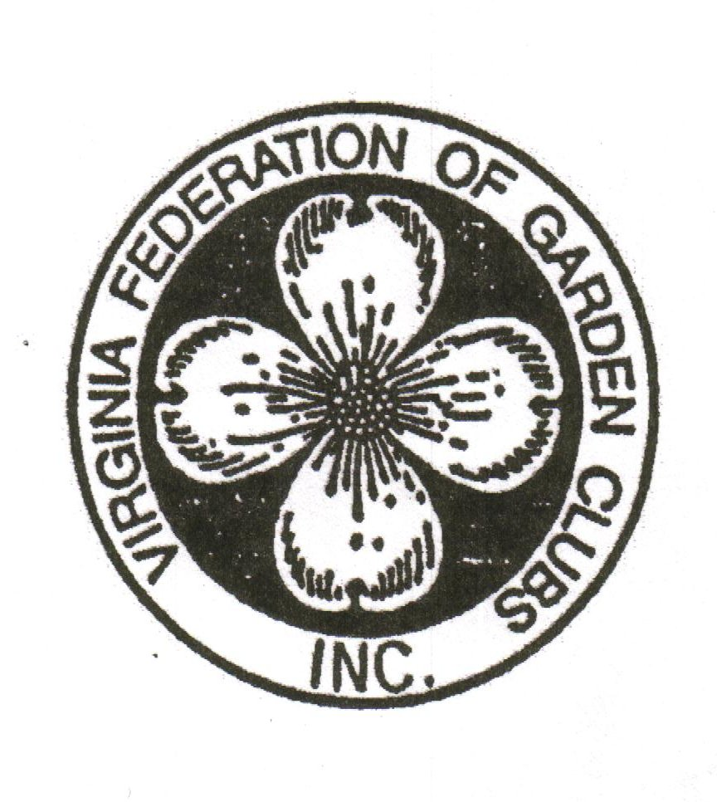

LANDSCAPE DESIGN SCHOOL

Course 1, Series 30
Monday and Tuesday
October 13, 14, 2025

Lewis Ginter Botanical Garden
Education Classroom
1800 Lakeside Drive
Richmond, VA 23228-4700

Phone (804) 693-9393

Sponsored by

VIRGINIA FEDERATION OF GARDEN CLUBS, INC.

